**1.Kill processes by name**

* ps aux grep firefox is only showing the **grep command itself**, not an actual Firefox process.  
  So when you run kill 8674, Linux says **“No such process”** because that PID already exited and Firefox was not running.

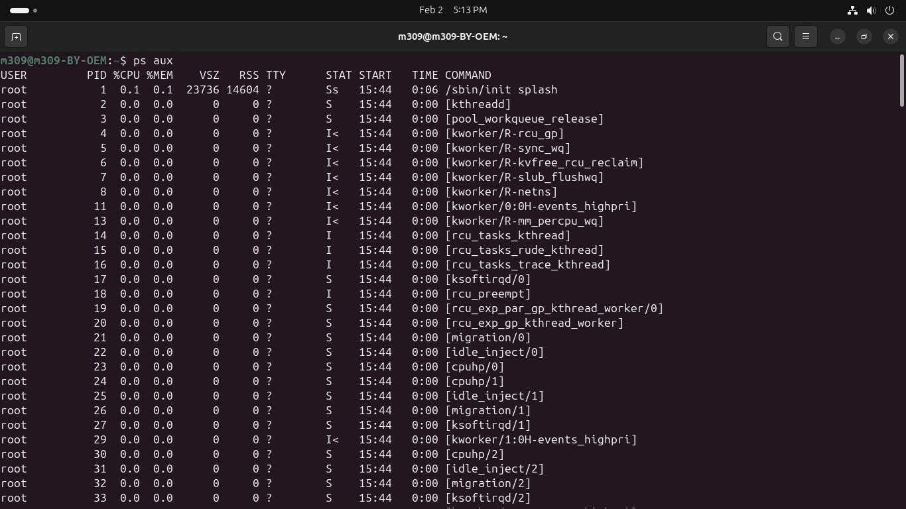

**2.Kill a process based on the process name**

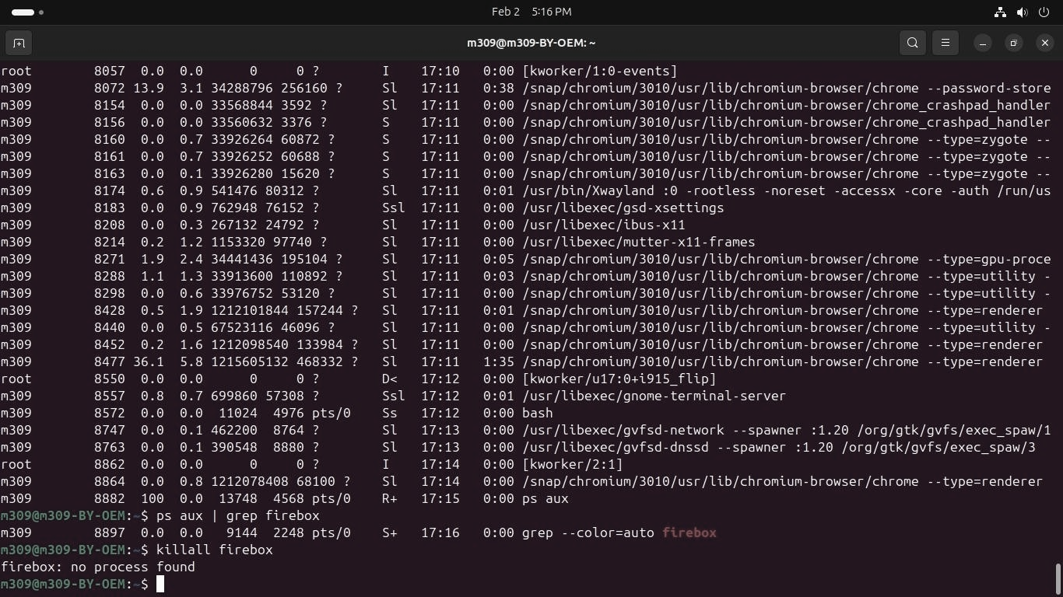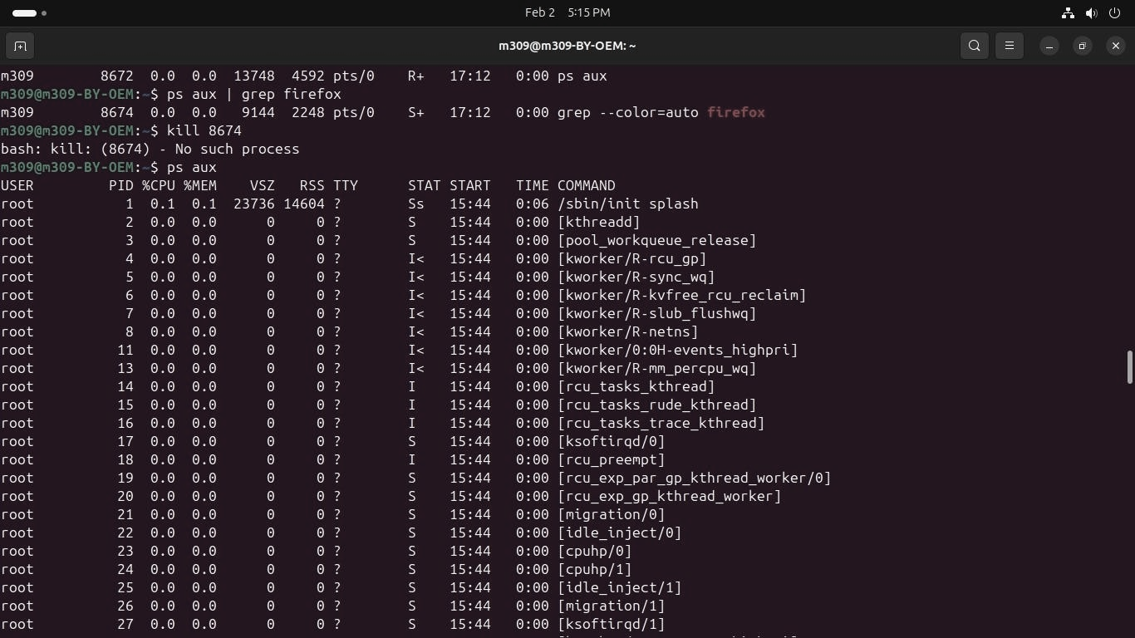 ps aux | grep firefox is only matching the grep command itself, meaning Firefox is not running.So kill 8674 and killall firefox fail because there is no Firefox process to terminate**.**

**3.Kill a single process at a time with the given process ID**

ps aux | grep chrome shows **many Chrome child processes**, and PID **8156** exited on its own before the kill command ran. So kill and kill -9 return **“No such process”** because that specific PID no longer exists.

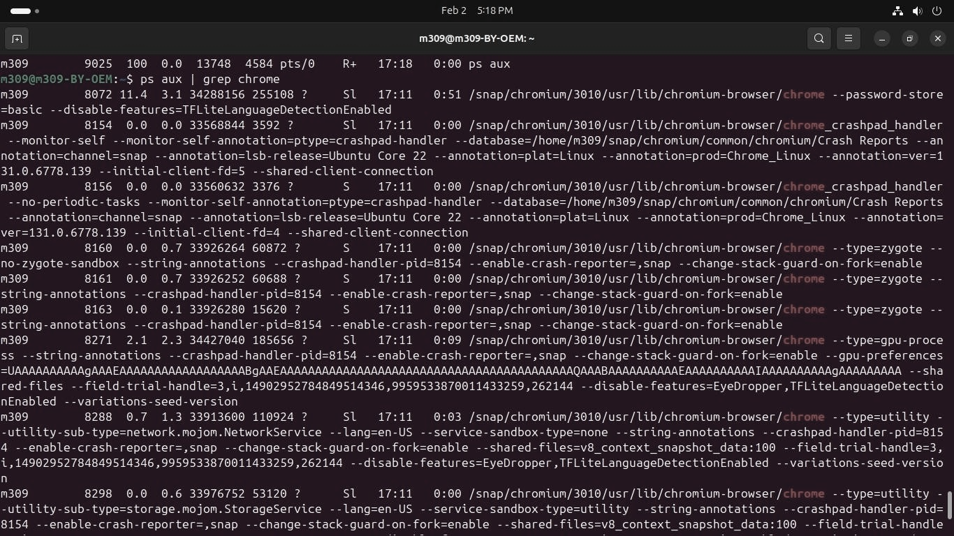

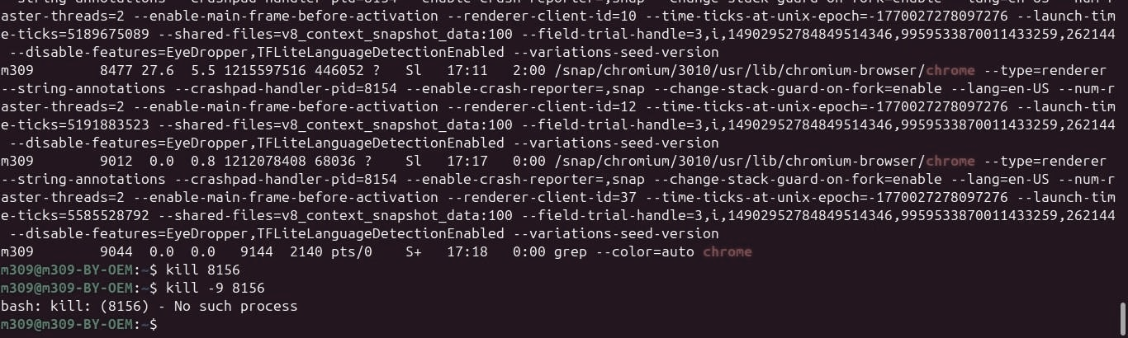

**2.Write a program for process creation using C**

* + Orphan Process

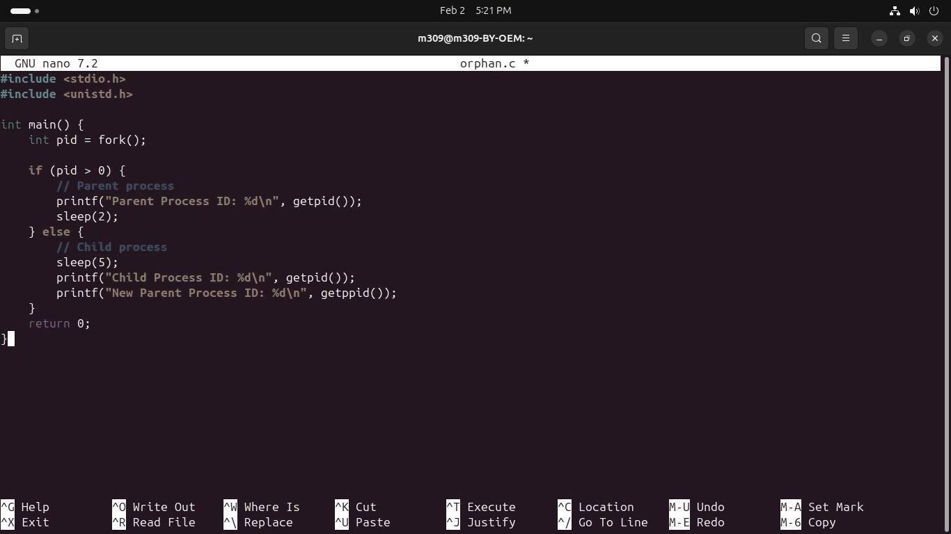

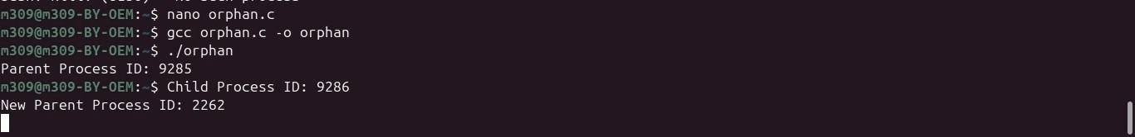

* + Zombie Process

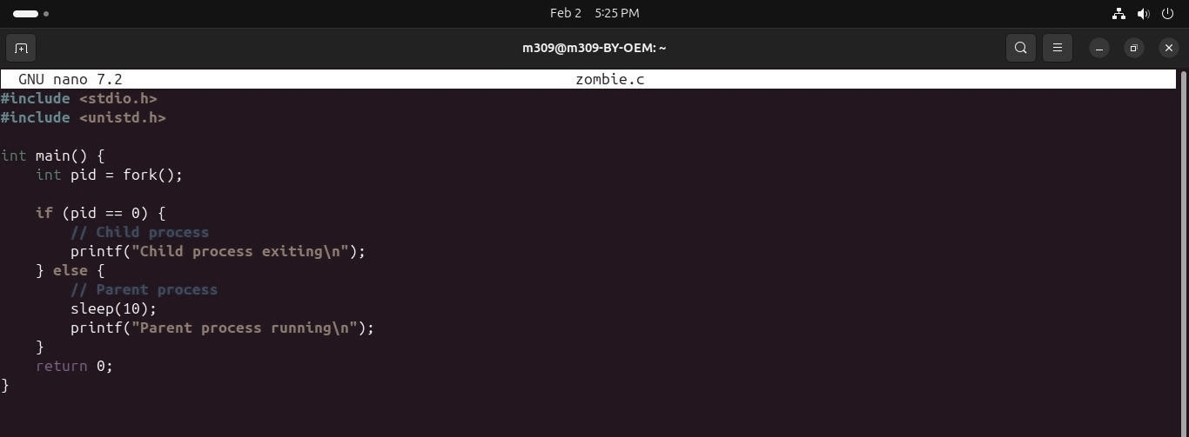

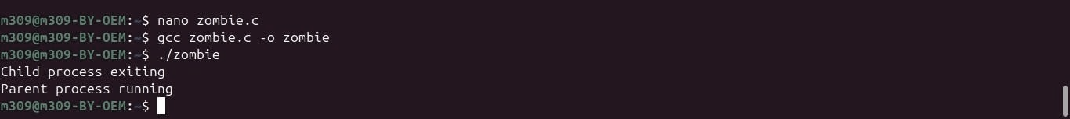

**3.The process using fork () system call**.

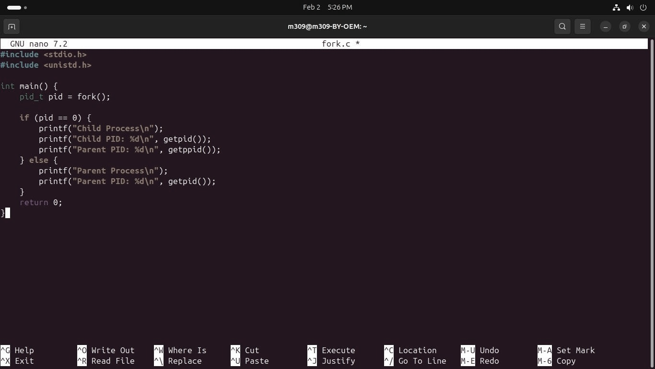

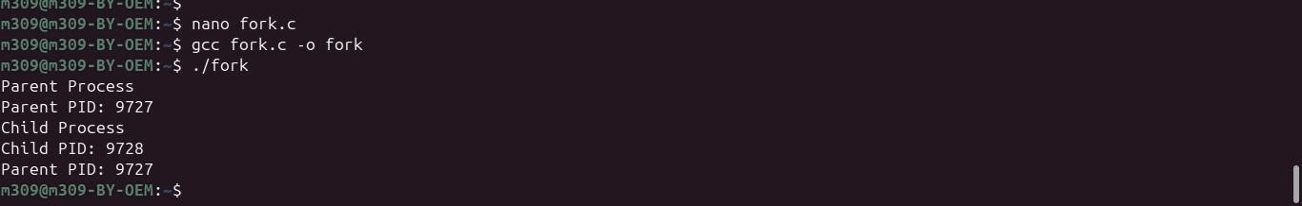

* + **Infinite loop on fork**

